**Tip: Tab 7--Getting Started on Notices and Motions**

- Get up and running in 60 (to 120) seconds. Admin note: Upon receipt of a motion, email the motion to the CP, Chief & NCOIC of Justice within 24 hours

**- To Set Up Notice Memoranda Format:**

-- Place your letterhead at the top of the [sample memo](Sample%20Notice%20Memo.docx)

-- Save the document in the Trial Notebook, Tab 7, as “Notice of ___, US v ___”

--- See the [List of Notices](List%20of%20Notices.docx) for common and possible notices in your case

-- Open sample memo, select all, copy, and paste your memo with letterhead and signature block

-- Fill in the headings in the To, From, and Subject

-- You’re ready to draft the notice (*and see* **JAJG Sharepoint, “Basic Templates”**)

<https://cs3.eis.af.mil/sites/afjagc/AFLOA/JAJ/JAJG/field/Basic%20Templates/Forms/AllItems.aspx>

**--** Notice of an issue sent by email may save you if formal notice has not been provided

**- To Set Up Motion Format:**

-- Open [Sample Motion](Sample%20Motion%20Template.docx) and save as “Motion to ___, US v ____”

-- You don’t even need to copy and paste because there is no letterhead

-- Fill in the headings and the signature block

-- Put the type of motion below the date and in the first paragraph, and you’re ready to go

**--** *See* **JAJG Motions Databank** for sample motions on specific topics

<https://cs3.eis.af.mil/sites/afjagc/AFLOA/JAJ/JAJG/field/Motion%20Bank/Forms/AllItems.aspx>

**- JAJG Sharepoint** has templates, samples, and links to other sites for motion research <https://cs3.eis.af.mil/sites/afjagc/AFLOA/JAJ/JAJG/field/Pages/Home.aspx>

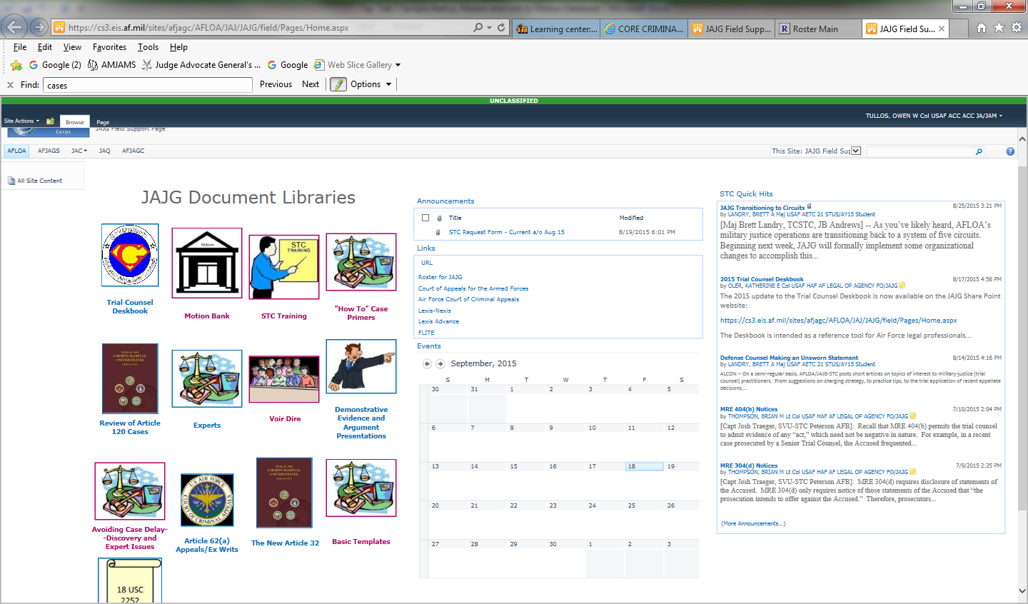

Basic Templates

AFCCA

CAAF

Lexis-Nexis

Motions Databank